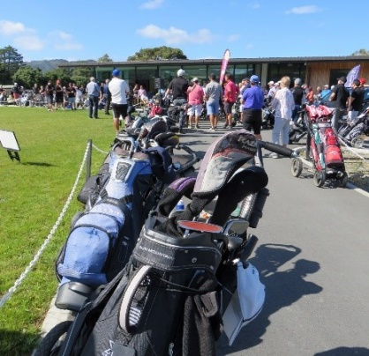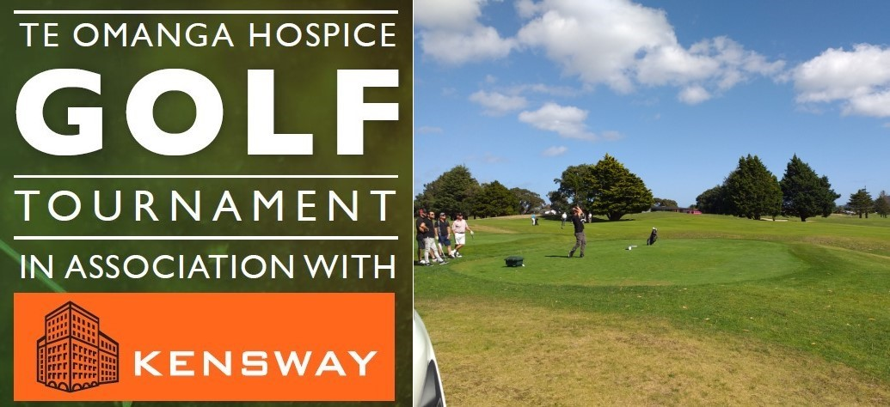
GOLF TOURNAMENT REGISTRATION
Tournament: Friday 24 February 2023
Time: 11am arrival for shotgun start at Midday
Where: Boulcott’s Farm Heritage Golf Club, 33 Military Rd, Lower Hutt
Format: Ambrose, BBQ, nibbles & beverages throughout the day, prizes, raffles and auctions
Team name:
Player 1: |  |  | *Handicap:
Player 2: |  |  | *Handicap:
Player 3: |  |  | *Handicap:
Player 4: |  |  | *Handicap:
Captain contact details | Ph: | Email:
*Maximum handicaps 18 (Men) & 24 (Women) or your professional handicap

 | $2500 for Hole Sponsorship and team of 4 OR |  | $600 for team of 4

For more information please contact Debbie Ferrel on 04 886 5210.
Please send completed form to events@teomanga.org.nz
Payments can be made to our Te Omanga Hospice bank account 06-0507-0816463-00 Ref: Golf
Or contact Debbie to request an invoice.
All proceeds will help Te Omanga Hospice provide compassionate care and support to people living with a terminal or life limiting illness in the Hutt Valley.

